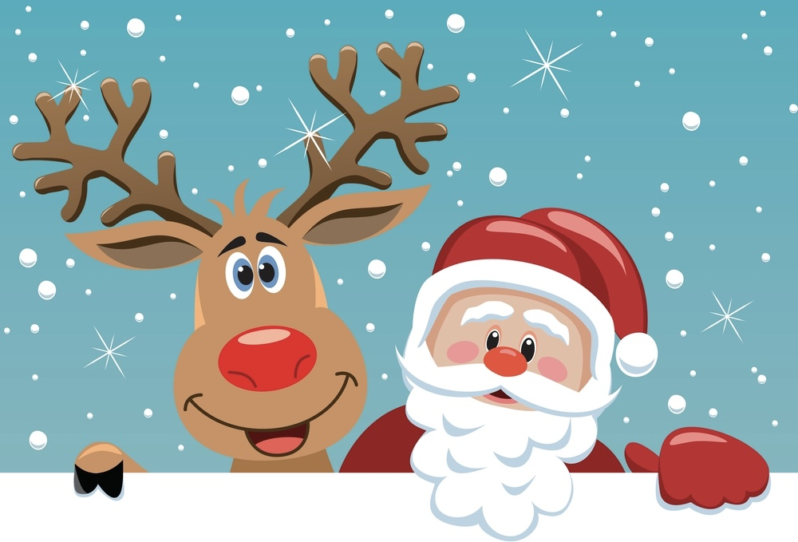  mt. Albert & district lions santa claus parade  Saturday dec. 7th @ 11am  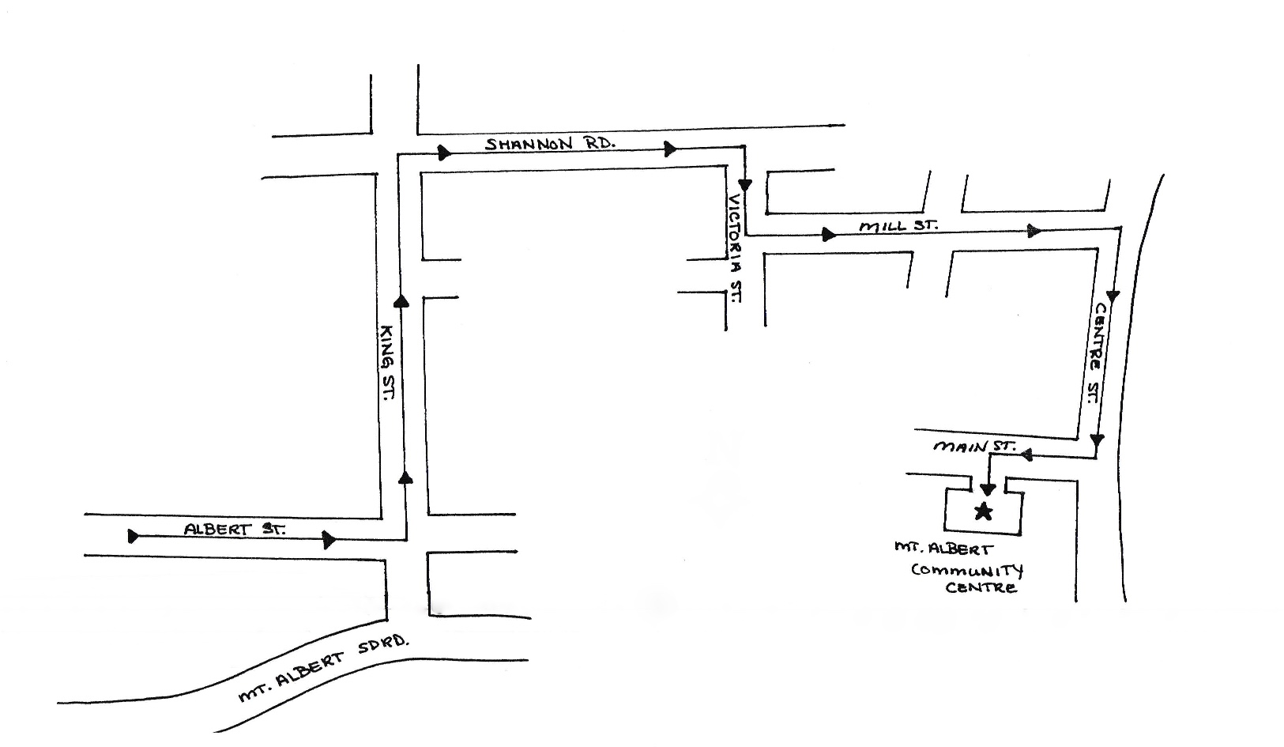 | Meet with Santa at the Mt. Albert Community Centre  ────  come inside for Free Hot dogs and hot chocolate for all  ────  Candy and entertainment for the kids  ────  Help your community: toys, donations & Non-perishable food items will be collected along the parade route  Parade Route:  The parade route moves north on King St, turns east on Shannon Rd, south on Victoria St, east onto Mill St, south on Centre St, and turns west onto Main St to the Mount Albert Community Centre. Roads will be closed along the parade route at 10:50am

